CURRICULUM VITAE

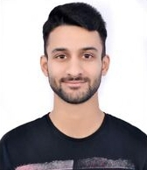
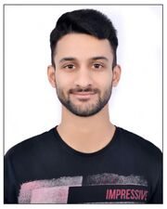
RISHI PANTHRI
P-48/III, Vikas Bhagan (Colony),
Roshnabad (Sidkul), Uttarakhand
Rishisharma193@gmail.com
+91 9837988669

CAREER OBJECTIVE
To utilize my skills and knowledge to serve your organization to the best of my ability and learn with practice and experience, thus, enhancing my skills and knowledge.

ACADEMICS
YEAR | CERTIFICATE | SCHOOL/COLLEGE | BOARD | RESULT
2017 | B.Com (Honors) | Uttaranchal University, Dehradun | Deemed | 75%
2013 | 12th | Army Public School-1 | CBSE | 56.8%
2011 | 10th | Army Public School-1 | CBSE | 80%

KEY SKILLS & STRENGTH
- Flexible regarding working hours and variety of roles as required at times
- Confident and Leadership
- Innovative & Encourages Ideas
- Quick decision making ability
- Team player & people’s person
- Handle pressure effectively

COMPUTER SKILLS
- MS Office
- Adobe Photoshop
- Picture Remodeling [Collages]
- Fine basic computer knowledge

PARTICIPATION IN EXTRA-CURRICULAR ACTIVITIES
- Sports & Events
- Badminton (Inter-University Level)
- 1st Runner-up in Inter-College Badminton Tournament, Uttaranchal University
- Rank Holder in Yuva Fest 2014, 2015 & 2016, Uttaranchal University, Dehradun
- 1st Runner-up in Treasure Hunt [Team Event], Uttaranchal University, Dehradun
- Athletics (Inter-School Level)
- Cricket & Other Outdoor Activities

- Seminars & Meetings
- Financial Planning in Sankalp 2015, IIT Roorkee
- Sankalp Fest 2015, IIT Roorkee
- Digital Marketing & Enterpreneurship Program at Uttaranchal University, Dehradun

PERSONAL PROFILE
Father’s name Mr. K.C. Sharma Panthri
Mother’s Name Mrs. Sushila Panthri
Gender Male
D.O.B 20thfeb1996
Marital Status Unmarried
Language known Hindi & English

DECLARATION
I hereby declare that the above mentioned information is correct up to my knowledge and I bear the responsibility for the correctness of the above mentioned particulars.

RISHI PANTHRI

